CC3000 Notes

CC3000 Supported clock rate for SPI = 0-16MHz as per Datasheet, so set SPI clock rate on MCU accordingly
(strangely, CC3000 host programming guide says 0-26MHz)

CC3000 drives its IRQ low after chip select to indicate its readiness to receive bytes by SPI.
CC3000 drives its IRQ low in between data transmissions to indicate to host it has something to send to it.
CC3000 requires bytes to be sent to it MSB (most significant bit first).
CC3000 requires SPI clock and phase settings of CPHA 0 and CPOL 0.
CC3000 requires all data to be 16-bit aligned (if last byte is an odd number, add one byte (value 0) to pad)
CC3000 requires each packet to have a 5 byte header, followed by payload, followed by padding byte if needed:

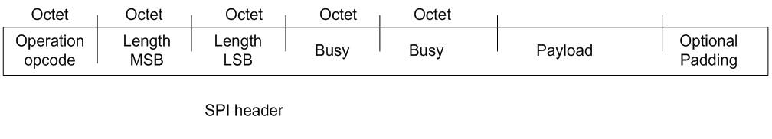
- opcode is one byte
- length of the payload (including padding byte) is given as two bytes, most significant byte first

Need to know which commands are the simplest request/response so I can test the chip.

SPI on Atmega168 MCU
- Must set PRSPI (PRR’s bit 2) to 0 to enable SPI module
- Set the SPI Interrupt Enable bit (SPIE) in the SPCR Register to have an interrupt requested after each byte is sent/received
- PB5 (pin 19) = SCK (Master clock output) (DDB5 must be set properly for this to be output
- PB4 (pin 18) = MISO (master input)
- PB3 (pin 17) = MOSI (master output) (DDB3 must be set properly for this to be output)
- PB2 (pin 16) = SS (slave select) (DDB2 must be set properly for this to be output)
- (see DDRB for DDBn values)

- Interrupt 0x0022 is SPI STC (serial transfer complete)
- Send byte by writing to it to SPDR after pulling SS low
- Read from SPDR reads byte that was received from slave during last byte xmit
- SPI uses the I/O clock, not the CPU clock

Master pulls SS low to select the slave.
Master and slave put data into their respective registers.
Master generates required clock cycles on SCK to interchange data.
After each data packet (series of bytes), master pulls SS high to synchronize slave.

CPU Clock | Div | Output Clock
14745600 | 2 | 7372800
 | 4 | 3686400
 | 8 | 1843200
 | 16 | 921600
 | 32 | 460800
 | 64 | 230400
 | 128 | 115200

Code must:
- Set DDB3 (MOSI) and DDB5 (SCK) to 0 (making them output lines)
  - MISO is auto configured as input when MCU is configured as master
- Set SPE of SPCR (bit 6) to 1 to enable SPI
- Set DORD of SPCR to 0 for Most-Significant-Bit-first transmission
- Set MSTR of SPCR to 1 to set MCU as SPI Master
- Set CPOL and CPHA of SPCR to 0
- Set SPR1 and SPR0 of SPRC to 0 (fastest clock speed : 1/4th)
- Set SPIF of SPSR to 0 (no interrupt)
- Set SPI2X in SPSR to 1 (for double speed: 1/2)
- Write 0 to SS
- While bytes-to-write
  - Write a byte to SPDR (SPI Data register)
    - Starts SPI clock
    - SPI shifts bits into the slave
    - After one byte, clock is stopped
    - SPIF (SPI end-of-transmission flag) is set
    - Interrupt request if SPIE (SPI Interrupt Enable) in SPCR is set
- Write 1 to SS

